**LAB 2**

This was the input string:

string str = "hello, world; {welcome to 2020} 2 + 3 = 5";

And this is the generated output based on the code on lexical_analysis.cpp:

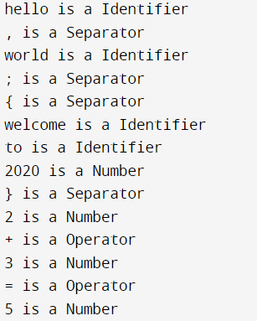

**Output explained:**

The scanner has identified tokens based on regular expression rules defined in the lexical_analysis.cpp file. For example, all digits are classified as numbers, while all letters whether in uppercase or lowercase strung together to form a word are classified as identifiers. Any parenthesis, square bracket or slash are classified as separators while any arithmetic sign is classified as an operator.